**Milestone Two - Enhancement One: Software Design/Engineering**

1. Briefly describe the artifact. What is it? When was it created?

The artifact I chose for Software Design/Engineering is my Final 3D Model scene, originally developed for CS330: Computational Graphics and Visualization. This project showcases a 3D scene that renders 4 total objects, one of them being an advanced object that incorporates more than one object. The three basic objects include two books and a post it note, while the advanced object is a medicine bottle (specifically Advil).

1. Justify the inclusion of the artifact in your ePortfolio. Why did you select this item? What specific components of the artifact showcase your skills and abilities in software development? How was the artifact improved?

I chose this artifact to enhance and include in my ePortfolio to tailor it toward game development and design as that is my targeted career area within Computer Science. When the artifact was first created, the scene was very basic, using minimal lighting standards, simple object textures and minimal operational functions. For controls, it included WASD movement controls, mouse input, and a simple perspective view for an orthographical perspective. In enhancing the project, I was able to improve the overall lighting to give it more of a lifelike feel, improved texturing that map to the faces of each object, and operational improvements including camera zoom, object focused perspectives (with selection options) and axis focused points (also with selection options).

1. Did you meet the course outcomes you planned to meet with this enhancement in Module One? Do you have any updates to your outcome-coverage plans?

In an effort to meet course requirements, I chose to aim this artifact enhancement toward course outcomes #3 and #4. Based on the overall design and and functionality of the scene, I feel that I meet #3’s requirements for designing and evaluating solutions that solve a problem while managing the trade-offs involved in the design choices. Each enhancement piece was designed to improve the scene both visually and operationally. Both areas of enhancements were added to the project based on its design and with design choice trade offs in mind. In meeting course outcome #4, I was able to demonstrate my ability to use innovative skills to implement solutions that provide value and accomplish the given goals. The visual enhancements improved the overall look of the project, making it more profound while the operational enhancements showcased increased functionality and with interactivity in the scene.

1. Reflect on the process of enhancing and modifying the artifact. What did you learn as you were creating it and improving it? What challenges did you face?

In reflection on the process of providing enhancements to this project, I learned a lot while running into a few different issues. Granted, CS330 was my first time working with OpenGL in creating a 3D scene. When it comes to game development software like Unreal Engine, I am a little more well-versed, but this course was a learning experience for me. While working on these enhancements, I started with the operational enhancements first. I figured that if I got the project working the way it needed to, I would feel more confident in finishing up with the visuals. It also helped to have the Zoom and Object Focused Perspectives in place when mapping the textures for testing, so I didn’t have to fly around the scene every time I loaded it up. In most cases, I simply just loaded the viewport, selected the object I wanted to focus on with the 1-4 keys, and used the scroll wheel to zoom in if I needed to. The main reason the objects didn’t have proper texture mapping for the CS330 submission is that I had to meet a deadline and didn’t have enough time to map the textures. When it came to mapping them for this course, I quickly remembered why, but I was able to map the textures correctly and provide a great visual. I also had challenges with the lighting interacting with specific materials. Some materials were too shiny while others were too dull, and knowing when it was the light intensity vs the material shine was tricky sometimes. Overall, I learned a lot from this experience and feel more confident in my 3D texture mapping, lighting, and operational enhancement implementation.

**Artifact Images:**  
  
Reference Image

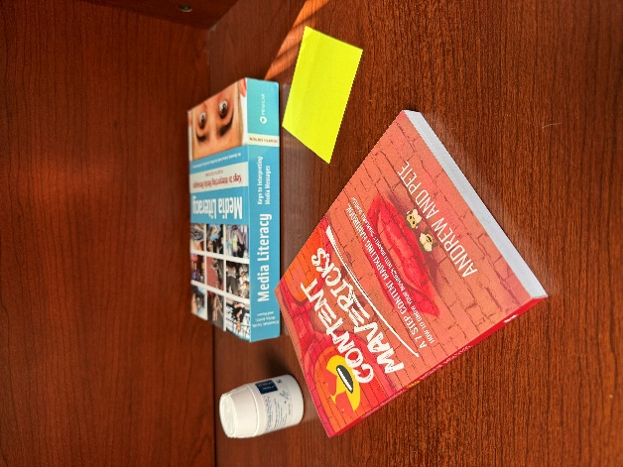

Before Enhancement

After Enhancement

